 | 7.1.15 Editors - 3D Viewport - Header - Mesh - Sculpt mode - Mask menu
Table of content
Sculpt Mode - Mask Menu 1
Invert Mask 1
Fill Mask 1
Clear Mask 2
Smooth Mask 2
Sharpen Mask 2
Grow Mask 2
Shrink Mask 2
Increase Contrast 2
Decrease Contrast 2
Expand Mask by Topology 2
Expand Mask by Curvature 2
Mask Extract 2
Threshold 3
Add Boundary Loop 3
Smooth Iterations 3
Project to Sculpt 3
Extract as Solid 3
OK 3
Mask Slice 3
Mask Slice and fill Holes 3
Mask Slice to new Object 3
Mask from Cavity 3
Mask from Mesh Boundary 3
Mask from Boundary Last Operator Panel 4
Mode: 4
Mix Factor: 4
Mode: 4
Propagation Steps: 4
Mask from Face Sets Boundary 4
Random Mask 4

Sculpt Mode - Mask Menu
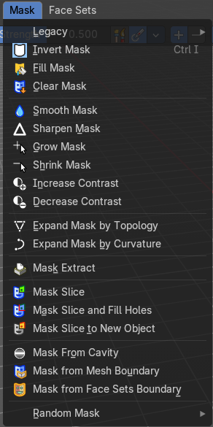

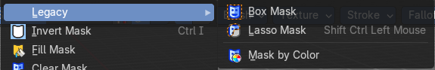
Legacy Sub-menu
Contains legacy operators also found the in the toolshelf as modal operations.

Box mask
Select a part of the mesh by box select.

Lasso Mask
Select a part of the mesh by lasso select.

Mask by Color
Select a part of the mesh by its color. Note that this does not work with a multiresolution modifier at the mesh. You will get a warning that multires is not supported.

Invert Mask
Inverts the mask.

Fill Mask
Fills the mask with a given value, or inverts its values.

Clear Mask
Clears the mask.

Smooth Mask
Smoothens the mask selection.

Sharpen Mask
Sharpens the mask selection.

Grow Mask
Grows the mask

Shrink Mask
Shrinks the mask.

Increase Contrast
Increases the contrast between masked parts and not masked parts.

Decrease Contrast
Decreases the contrast between masked parts and not masked parts.

Expand Mask by Topology
Expands the mask from the initial active vertex under the mouse. Starts with a new mask.
Watch the tool tip in the footer for further instructions.

Expand Mask by Curvature
Expands the mask from the initial active vertex under the mouse. Keeps the previous mask.
Watch the tool tip in the footer for further instructions.

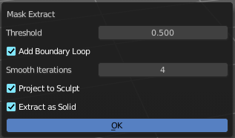
Mask Extract
Creates a new object out of the masked mesh part.
This operation cannot be undone!

Threshold
The sharpness of the mask border.

Add Boundary Loop
Add a boundary loop at the border of the new created geometry. This can help to make the geometry more stable.

Smooth Iterations
How many iterations to smooth the new created geometry.

Project to Sculpt
Project the extracted mesh into the original sculpt.

Extract as Solid
Extract the new created mesh as a solid mesh.

OK
Apply the Mask Extract tool.

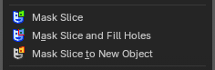
Mask Slice
Slices the paint mask from the mesh.

Mask Slice and fill Holes
Slices the paint mask from the mesh. And fills existing holes.

Mask Slice to new Object
Slices the paint mask from the mesh, and creates a new object out of it.

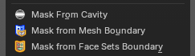
Mask from Cavity
Creates a mask based on cavity and pointiness of the mesh.

Mask from Mesh Boundary
Creates a mask along the topological boundaries of the mesh—edges where geometry ends or is disconnected.

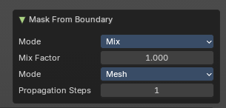
Adjust last operator Mask from Boundary

Mode:
Defines how the mask interacts with existing masks. Controls how the new mask blends with any existing mask (e.g. Mix, Add, Subtract).

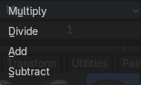
Mix Factor:
Controls blending strength.

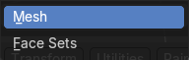
Mode:
Either Face Sets mode or Boundary mode.

Propagation Steps:
Determines how far the mask spreads from the boundary.

Mask from Face Sets Boundary
Generates a mask along the boundaries between face sets—regions defined by sculpting tools or manual assignment.

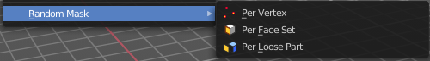
Random Mask
Masks out random parts of the mesh by the chosen method.

